FORM HCP002 www.pelvicpaineducation.com

- This form is intended to help you evaluate patients with pelvic pain by walking you through the physical exam and providing guidance on formulating an assessment and plan.
- This form can be used for documentation, however, note that the patient history is collected through the initial patient history survey.
- IMPORTANT PRIVACY AND SECURITY NOTICE: The questionnaires below are collect private health information (PHI). The questionnaires should be destroyed or securely stored in the patient record after they are completed. DO NOT mail, fax, or email them to patients, unless these modes of communication are equipped with encryption and security measures designed to transfer private health information.
pelvic pain assessment form for healthcare professionals

PATIENT IDENTIFIERS
Note: If you are collecting HIPAA / HPI you must ensure these forms are secured.
Physical Examination Date:Click or tap here to enter text.
Last Name: Click or tap here to enter text.
First Name: Click or tap here to enter text.
ID Number:Click or tap here to enter text.
EXAMINATION
General Appearance: (Check all that apply)
☐Well-appearing ☐Ill-appearing ☐Tearful ☐Depressed
☐Normal weight ☐Underweight ☐Overweight
☐Abnormal Gait ☐Other:Click or tap here to enter text.

Head, ears, nose and throat: ☐Normal ☐Other: Click or tap here to enter text.
Lungs: ☐Normal ☐Other: Click or tap here to enter text.
Heart: ☐Normal ☐Other: Click or tap here to enter text.
Abdomen:
☐Normal ☐Non-tender ☐Tender ☐Inguinal tenderness
☐Mass ☐Inguinal bulge ☐Suprapubic tenderness ☐Guarding ☐Rebound ☐Distention
☐Sensory abnormality (allodynia or hyperalgesia) Location:Click or tap here to enter text.
☐Positive Carnet’s sign
☐Trigger Points: Number:Click or tap here to enter text. Location:Click or tap here to enter text.
☐Surgical scars: Number: Click or tap here to enter text. Location:Click or tap here to enter text.
☐Surgical scar pain present (describe location and severity):Click or tap here to enter text.
☐Other, including pain severity and radiation patterns, describe all abnormalities here:Click or tap here to enter text.
Musculoskeletal (External):
Musculoskeletal Structure | Findings |  | Description
Gait | ☐Normal ☐Abnormal |  | ☐Knee pain  ☐Leg discrepancy  ☐OtherClick or tap here to enter text.
Posture | ☐Normal ☐Abnormal |  | ☐Pelvic tilt  ☐Kyphosis  ☐Scoliosis  ☐Other:Click or tap here to enter text.
Lumbar range of motion | ☐Normal ☐Abnormal |  | ☐Painful with flexion  ☐Painful with extension  ☐Painful with rotation  ☐Painful with side bending
Pubic symphysis | ☐Normal ☐Abnormal |  | ☐Painful with palpation  ☐Separation noted
Rectus abdominus | ☐Normal ☐Abnormal |  | ☐Painful with palpation  ☐Separation >2.7cm noted
Hernia regions (Ventral, Inguinal) | Normal ☐Abnormal |  | ☐Ventral hernia present >2cm  ☐Inguinal hernia present
 |  | Normal |  | Painful RIGHT | Painful LEFT
Sacroiliac joints
Active straight leg raise test
Hip flexion
Hip Ab/Adduction

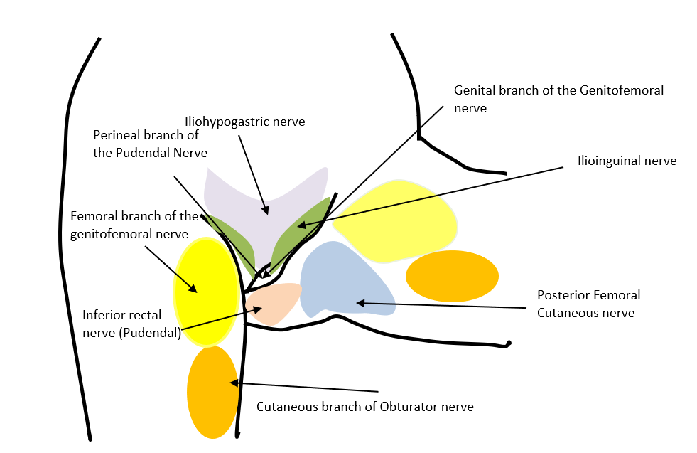
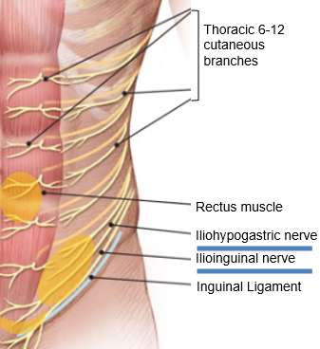
Neurologic (External):
Illustration by Michael Hibner
Illustration by Christy Krames, aafp.org
Nerve | Finding |  | RIGHT |  | LEFT
 | Normal | Abnormal | Allodynia | Hyperalgesia | Allodynia | Hyperalgesia
Iliohypogastric | ☐ | ☐ | ☐ | ☐ | ☐ | ☐
Ilioinguinal | ☐ | ☐ | ☐ | ☐ | ☐ | ☐
Genitofemoral | ☐ | ☐ | ☐ | ☐ | ☐ | ☐
Posterior femoral cutaneous | ☐ | ☐ | ☐ | ☐ | ☐ | ☐
Lateral femoral cutaneous | ☐ | ☐ | ☐ | ☐ | ☐ | ☐
Pudendal | ☐ | ☐ | ☐ | ☐ | ☐ | ☐
Obturator | ☐ | ☐ | ☐ | ☐ | ☐ | ☐

Body Pain Map:
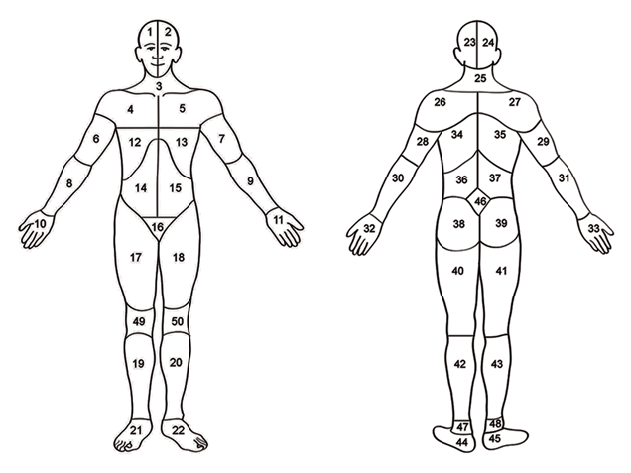
List the numbers of all the sites where the patient reports pain:Click or tap here to enter text.

Add comments, including pain severity and radiation patterns:Click or tap here to enter text.
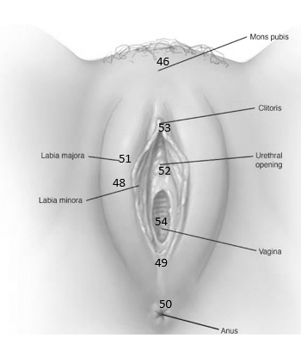
External Visual Examination of Genitalia:☐Normal ☐Atrophy
☐Discharge ☐Bleeding
☐Masses, Lesions; Describe:Click or tap here to enter text.
12 o’clock
☐Hyperkeratosis; Location: Click or tap here to enter text.
☐Tenderness; Location:Click or tap here to enter text.
☐Vestibular erythema; Location:Click or tap here to enter text.
Posterior fourchette (49)
☐Allodynia; Location:Click or tap here to enter text.
☐Hyperalgesia; Location:Click or tap here to enter text.
6 o’clock
Note, describe pain location, radiation and abnormalities in further detail here using location numbers:Click or tap here to enter text.
Illustration by Georgine Lamvu

Single Digit Pelvic Floor Muscle Examination (Note- assess tenderness, tone, strength and voluntary control).
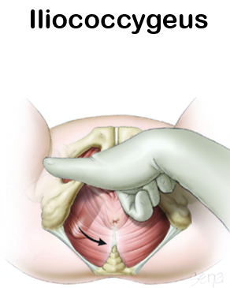
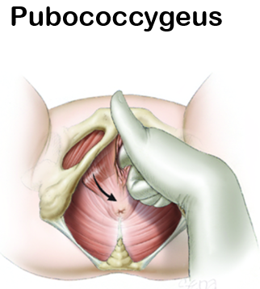
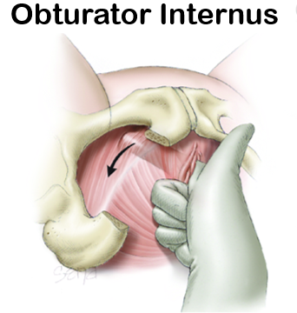
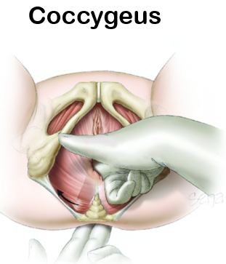
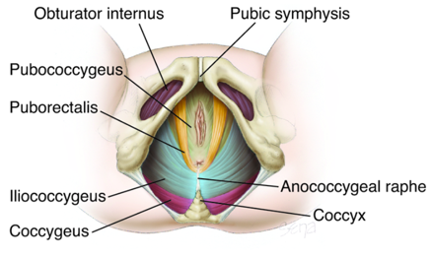
Hoffman BL, Schorge JO, Bradshaw KD, Halvorson LM, Schaffer JI, Corton MM. Williams Gynecology, 3e; 2016

Coccyx: ☐Tender ☐Non-tender

Tenderness with compression of ischial spine: ☐Non-tender right ☐Tender right
☐Non-tender left ☐Tender left
If tender, is the pain in the distribution of the pudendal nerve when the ischial spine is compressed (Valleix sign): ☐Yes ☐No
Pelvic floor muscle assessment:
Muscle | Tenderness (0-4) |  |  |  |  | Baseline Tone  (0-4) |  |  |  |  | Strength  (0-4) |  |  |  |  | Voluntary Control
 | 0 | 1 | 2 | 3 | 4 | 0 | 1 | 2 | 3 | 4 | 0 | 1 | 2 | 3 | 4 | Present | Absent
Right obturator internus | ☐ | ☐ | ☐ | ☐ | ☐ | ☐ | ☐ | ☐ | ☐ | ☐ | ☐ | ☐ | ☐ | ☐ | ☐ | ☐ | ☐
Left obturator internus | ☐ | ☐ | ☐ | ☐ | ☐ | ☐ | ☐ | ☐ | ☐ | ☐ | ☐ | ☐ | ☐ | ☐ | ☐ | ☐ | ☐
Right Pubococcygeus | ☐ | ☐ | ☐ | ☐ | ☐ | ☐ | ☐ | ☐ | ☐ | ☐ | ☐ | ☐ | ☐ | ☐ | ☐ | ☐ | ☐
Left Pubococcygeus | ☐ | ☐ | ☐ | ☐ | ☐ | ☐ | ☐ | ☐ | ☐ | ☐ | ☐ | ☐ | ☐ | ☐ | ☐ | ☐ | ☐
Right Coccygeus | ☐ | ☐ | ☐ | ☐ | ☐ | ☐ | ☐ | ☐ | ☐ | ☐ | ☐ | ☐ | ☐ | ☐ | ☐ | ☐ | ☐
Left Coccygeus | ☐ | ☐ | ☐ | ☐ | ☐ | ☐ | ☐ | ☐ | ☐ | ☐ | ☐ | ☐ | ☐ | ☐ | ☐ | ☐ | ☐
Right Iliococcygeus | ☐ | ☐ | ☐ | ☐ | ☐ | ☐ | ☐ | ☐ | ☐ | ☐ | ☐ | ☐ | ☐ | ☐ | ☐ | ☐ | ☐
Left Iliococcygeus | ☐ | ☐ | ☐ | ☐ | ☐ | ☐ | ☐ | ☐ | ☐ | ☐ | ☐ | ☐ | ☐ | ☐ | ☐ | ☐ | ☐
Right bulbocavernosus | ☐ | ☐ | ☐ | ☐ | ☐ | ☐ | ☐ | ☐ | ☐ | ☐ | ☐ | ☐ | ☐ | ☐ | ☐ | ☐ | ☐
Left bulbocavernosus | ☐ | ☐ | ☐ | ☐ | ☐ | ☐ | ☐ | ☐ | ☐ | ☐ | ☐ | ☐ | ☐ | ☐ | ☐ | ☐ | ☐

Internal Pelvic Examination:
Pelvic Structure | Findings and Description
Cervix | ☐Normal | ☐Tender  Describe:Click or tap here to enter text. | ☐Mass  Describe:Click or tap here to enter text.
Urethra | ☐Normal | ☐Tender  Describe:Click or tap here to enter text. | ☐Mass  Describe:Click or tap here to enter text.
Bladder | ☐Normal | ☐Tender  Describe:Click or tap here to enter text. | ☐Mass  Describe:Click or tap here to enter text.
Rectovaginal vault | ☐Normal | ☐Tender  Describe:Click or tap here to enter text.  Click or tap here to enter text. | ☐Mass  Describe:Click or tap here to enter text.
Vaginal apex (if cervix is absent) | ☐Normal | ☐Tender  Describe:Click or tap here to enter text. | ☐Mass  Describe:Click or tap here to enter text.

Bimanual Examination:

Uterus: ☐Normal ☐Absent
☐Tender ☐Anterior location ☐Posterior location
☐Enlarged size, enter size: Click or tap here to enter text.
☐Irregular shape ☐Fixed ☐Firm
☐Prolapse, describe stage: Click or tap here to enter text.

Adnexa: ☐Normal ☐Absent right ☐Absent left
☐Tender right ☐Tender left
☐Fixed right ☐Fixed left
☐Enlarged right: Click or tap here to enter text.
☐Enlarged left: Click or tap here to enter text.

Rectal: ☐Normal ☐Nodules ☐Hemoccult positive
☐Tenderness ☐Hemorrhoids ☐Other:Click or tap here to enter text.

Additional Comments: Click or tap here to enter text.

ASSESSMENT AND PLAN
Suspected Initial Diagnosis (Check all that apply)
Uro-Gynecologic
☐Endometriosis  ☐Adenomyosis | ☐Dysmenorrhea | ☐Fibroids
☐Ovarian cyst(s) | ☐Ovarian remnant | ☐Pelvic congestion syndrome
☐Dyspareunia | ☐Premenstrual Syndrome | ☐Genitourinary syndrome of menopause
☐Pelvic organ prolapse  ☐Cystocele  ☐Rectocele  ☐Cervical prolapse  ☐Uterine prolapse | ☐Vulvodynia  ☐Generalized  ☐Localized  ☐Spontaneous  ☐Provoked | ☐Vulvar pain with known etiology, list:
☐IC/BPS | ☐Urinary urgency | ☐Urinary frequency or Overactive Bladder
☐Urinary incontinence | ☐Urinary tract infection | ☐Urethral mass
☐Prostatitis (bacterial or non-bacterial) | ☐Urethritis | ☐Prostate mass or BPH
☐Sexually transmitted infection | ☐Orchitis, Scrotal pain | ☐Urethral or bladder stones
Gastroenterologic
☐IBS-Diarrhea | ☐IBS-Constipation | ☐IBS-Mixed
☐Diarrhea | ☐Constipation | ☐Fecal incontinence
☐Dyschezia | ☐Inflammatory bowel disease | ☐Diverticulosis/itis
Neurologic
☐Neuralgia  List site: | ☐Pudendal neuropathy
Non-Genital Pain Syndromes
☐Chronic fatigue | ☐Fibromyalgia | ☐Migraines / Headaches
☐TMD | ☐Chronic low back pain
Musculoskeletal
☐Pelvic floor muscle dysfunction | ☐Myalgia | ☐Specific muscle, e.g. piriformis, obturator, or levator tenderness
Psychosocial
☐PTSD | ☐Sexual trauma / abuse | ☐Physical abuse
☐Depression | ☐Anxiety | ☐Suicide ideation or intent
☐Sleep disorder | ☐Catastrophizing | ☐Rumination
☐Substance abuse | ☐Opioid use ☐Opioid abuse ☐Opioid side effects
Pain Descriptors
☐Pelvic Pain | ☐Chronic pelvic pain | ☐Chronic pain syndrome
Other Diagnoses not listed above:Click or tap here to enter text.

Recommended treatments
☐Acupuncture ☐Massage ☐Nutrition/Diet ☐Physical Therapy ☐Biofeedback
☐Trigger Point Injections ☐TENS Unit ☐Botox Injections ☐Nerve Blocks
☐Epidural ☐Sex Therapy ☐Joint Injections ☐Neurostimulation
☐Mental Health ☐Bladder instillations ☐Aqua Therapy ☐Radio Frequency Ablation
☐Cognitive Behavioral Therapy ☐Percutaneous Tibial Nerve Stimulation ☐NONE
☐Hormonal treatment-- if yes, what type of hormonal treatment? (Check all that apply)
☐Pills ☐Patch ☐Ring ☐ Injections ☐Estrogen ☐Progesterone
Other treatments:Click or tap here to enter text.

Recommended Pharmacotherapy
Medication | Dose | Instructions for use
☐NONE
Recommended Surgery
Surgery Name | Primary Indication for surgery
☐NONE
Referrals
☐Gastroenterology ☐Urology ☐Urogynecology ☐Reproductive Endocrinology and Infertility
☐Endocrinology ☐Medicine ☐Primary care ☐Pain management ☐NONE
☐Other:Click or tap here to enter text.

Additional psychosocial or medical factors contributing to pain:
Click or tap here to enter text.
Additional medical co-morbidities that impact pain not listed above in the ‘diagnosis’ section: Click or tap here to enter text.

Shared Decision Making and Goal Setting
Patient goals (should be focused and attainable)
Short-term:Click or tap here to enter text.
Long-term:Click or tap here to enter text.
Potential obstacles to attaining goals identified by patient and the provider:Click or tap here to enter text.
Shared decision making
Patient selected therapies: Click or tap here to enter text.
Treatments recommended by the provider but not accepted by the patient: Click or tap here to enter text.

